
Design Optimization Proposal for Enhanced Robotic Arm Responsiveness

1. Problem Statement
Identified Issues:
- Actuator Strain:
  - Description: Annotated design images indicate that the actuator at the robotic arm’s rotational joint is experiencing elevated mechanical strain during operation, particularly during repeated joint movements.

  - Impact: Excessive actuator strain can lead to slower joint response, increased wear, and reduced long-term durability. Over time, this strain may negatively impact the robotic arm’s precision and reliability during surgical procedures.

- Sensor Misalignment:
  - Description: Sensors located near joint interfaces appear misaligned, which may affect the accuracy and timing of feedback signals sent to the control system.

  - Impact: Misaligned sensors can introduce feedback delays or inaccuracies, reducing the effectiveness of closed-loop control. This can result in slower corrective actions and reduced real-time responsiveness during precision surgical tasks.

2. Proposed Modifications
Modification 1:
- Proposal: Replace the existing joint actuator with a lightweight, high-efficiency actuator and reinforce the joint using stronger, lightweight materials.

- Justification: Reducing actuator mass and improving mechanical efficiency lowers the load experienced during joint rotation. Reinforcing the joint enhances durability while maintaining stiffness, resulting in smoother motion, improved responsiveness, and increased reliability in surgical applications.
Modification 2:
- Proposal: Realign and recalibrate joint sensors to ensure accurate positioning and minimize feedback latency.

- Justification: Proper sensor alignment improves the accuracy and speed of feedback to the control system, enabling faster corrective actions and improved closed-loop control performance during fine surgical movements.

3. Simulation Results
- Initial Metrics:
  - Actuator Response Time: 0.20 seconds

  - Sensor Feedback Delay: Baseline feedback delay observed in the control loop (pre-optimization)

- Post-Optimization Metrics:
  - Actuator Response Time: 0.17 seconds

  - Sensor Feedback Delay: Reduced relative feedback latency after sensor realignment

- Key Insights:
  - Simulation results from the Robotic Arm Design Simulation notebook demonstrate that improving actuator efficiency and reducing feedback latency leads to measurable improvements in responsiveness and durability. The optimized configuration achieved faster response times and higher durability without introducing instability or compromising control precision. This represents a 15% reduction in actuator response time, demonstrating the effectiveness of the proposed design optimizations.

4. Annotated Visual Examples
Visual Example 1: Current Sensor Misalignment vs. Proposed Realignment
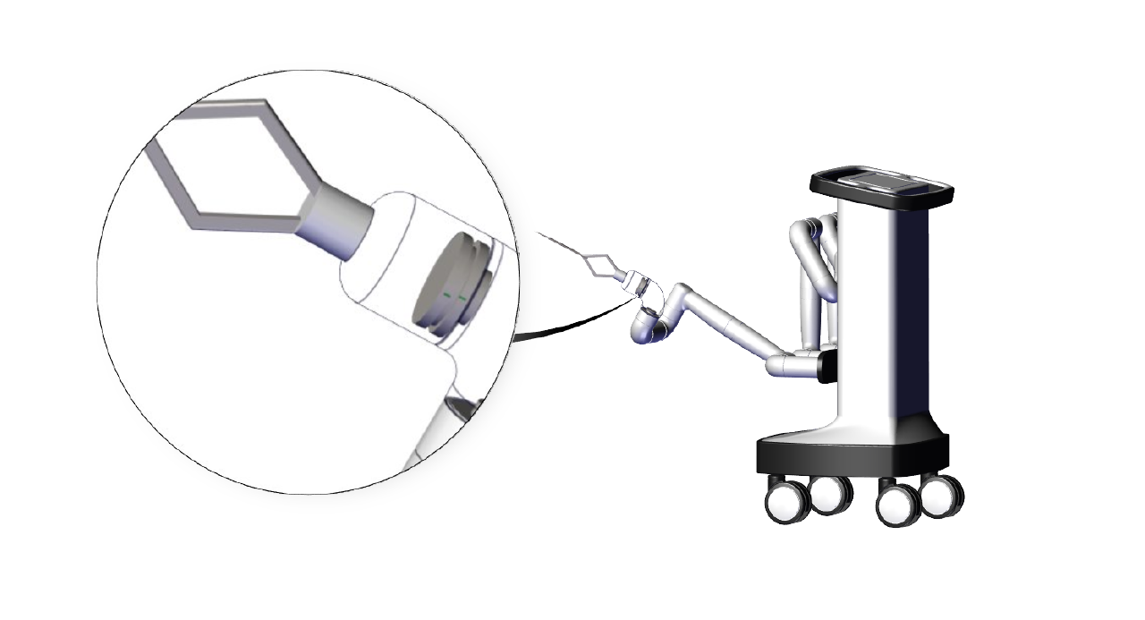
- Brief Description: This image highlights the sensor placement at the joint interface. The magnified view illustrates potential misalignment that may introduce feedback delays or inaccuracies. The proposed modification involves realigning and recalibrating the sensor to improve feedback accuracy and control responsiveness.

Visual Example 2: Actuator Upgrade Impact
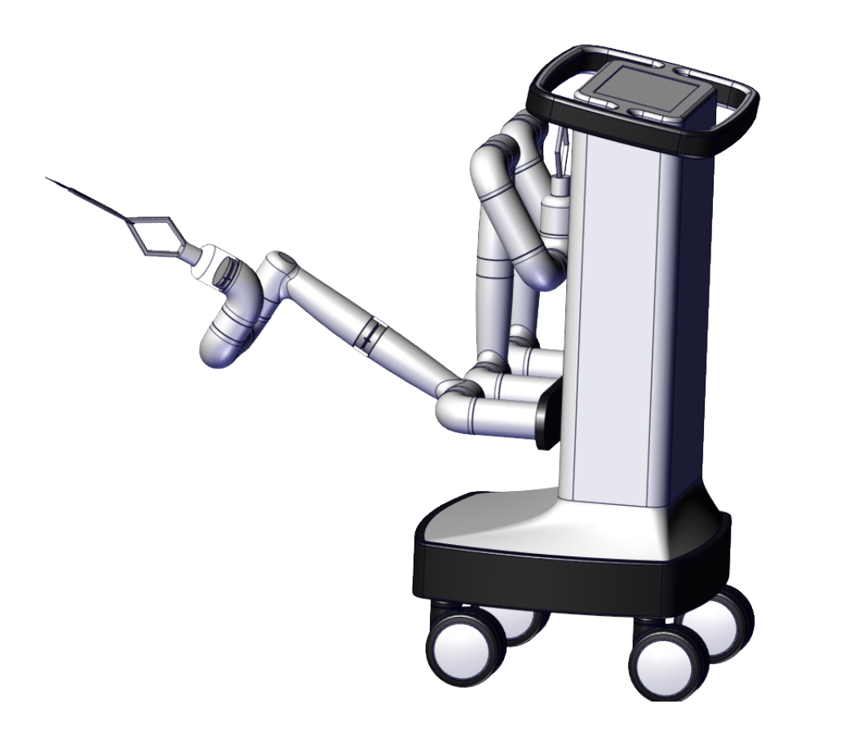
- Brief Description: This image highlights the robotic arm’s rotational joints and actuator configuration under load. The extended arm position illustrates areas where actuators experience increased mechanical strain. The proposed modification involves upgrading to a lightweight, high-efficiency actuator and reinforcing the joint structure to improve durability and maintain precise motion during surgical procedures.

5. Expected Outcomes
- Improved Responsiveness: Reduced actuator response time enables faster and smoother joint movements, improving real-time surgical precision.

- Enhanced Reliability: Improved actuator efficiency and sensor feedback accuracy increase system stability and consistency during prolonged surgical use.

- Increased Durability: Reinforced joints and reduced mechanical strain extend component lifespan and support long-term operational reliability.

6. Conclusion
Summarize the impact of your proposed modifications:
- The proposed design modifications address key performance limitations identified during diagnostics by reducing actuator strain and improving sensor feedback accuracy. Simulation results validate that these changes enhance responsiveness and durability while maintaining the precision required for surgical applications. Together, these optimizations improve system performance margins and support reliable, safe operation in high-stakes surgical environments. These enhancements support Johnson & Johnson’s commitment to delivering safe, precise, and reliable surgical robotic systems.

